Quick Start Guide

**OSC1-Lite**

*12-channel μLED Driver System*

*Version v1.0.0*

**CAUTION!**

**Do not turn off the power before disconnecting from the GUI.**

**Otherwise, it will damage the μLED.**

1. **Introduction**

The University of Michigan's OSC1-Lite chip serves to trigger user-defined optical stimulation on up to 12 different channels. Python GUI and library is available for interacting with OSC1-Lite stimulation system. The open-source code for the GUI interface is available at GitHub link: <https://github.com/YoonGroupUmich/osc1lite/releases>. We invite you to post issues and solutions there as well, which will help our scientific community as we have limited resources for supporting this device.

1. **System Setup**
   1. **Included Items**

(1 pcs) USB-A to USB-B Cable

(1 pcs) OSC1Lite System Board

(2 pcs) 18650 Li-Ion Battery

(1 pcs) Charger

(1 pcs) 1 meter Omnetics cable

* 1. **System Requirements**

The system only supports Windows operating system.

The recommended screen resolution of your PC is 1280x720 or above.

* 1. **Device Setup**

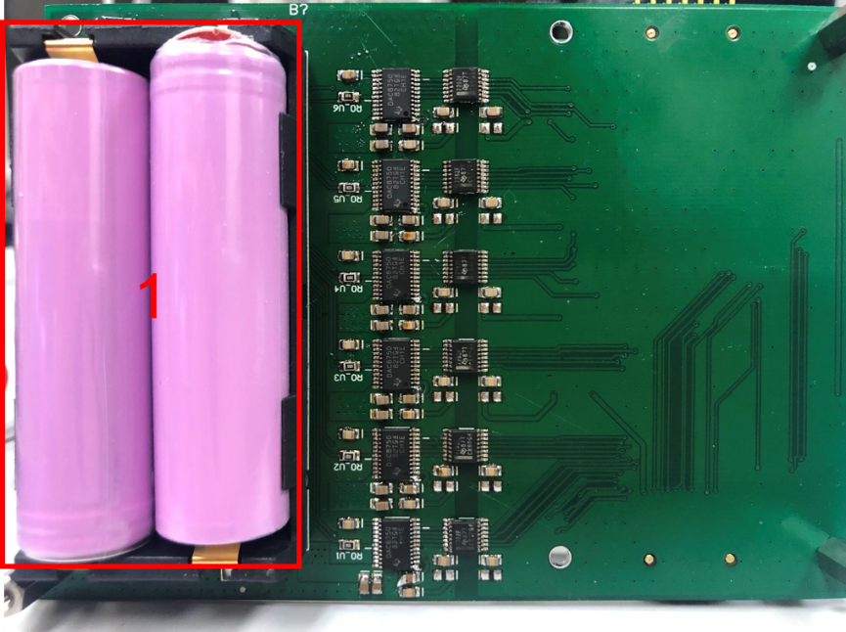

Figure 1 Back of the board

**Step 1:** Install two charged Li-Ion 3.7V batteries at the back of the board.

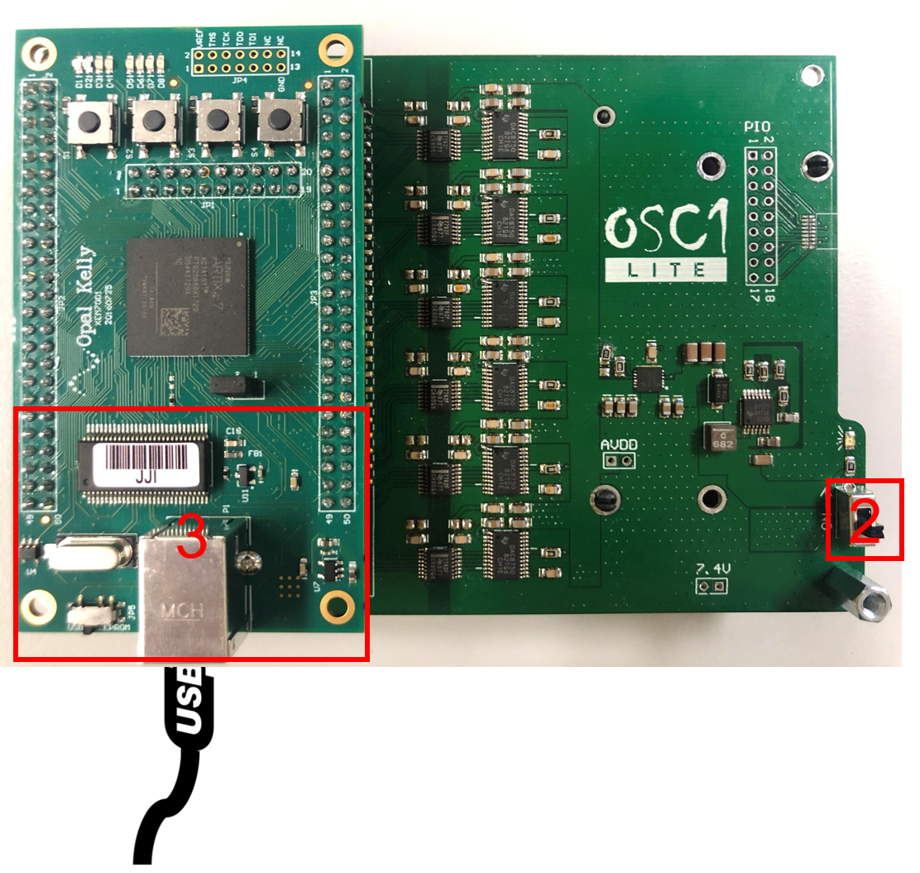

Figure 2 Front of the board

**Step 2:** Power Device on with Switch at the front of the board. An LED light indicates the system is on.

*Important:* *Do not turn off the switch/power before disconnecting from the GUI. Otherwise, it will damage the μLED.*

**Step 3:** Plug the included USB cable to the device and the computer with which you are using the GUI.

* 1. **Battery Check**

There are two LEDs on the board to help the user check the battery usage. Make sure to disconnect from the board and recharge the batteries when the green LEDs turn off.

1. **GUI Interface**
   1. **Installation**
2. **Installing Opal Kelly Frontpanel**

To use the OSC1-Lite library requires the installation of Opal Kelly FrontPanel. Install it use the following link.

<https://github.com/YoonGroupUmich/osc1lite/releases/download/v1.0.0/FrontPanelUSB-Win-x64-4.5.6.exe>

1. **Open GUI**

Download the oscgui.zip file using the following link and open the oscgui application.

<https://github.com/YoonGroupUmich/osc1lite/releases/download/v1.0.0/oscgui-win64.zip>

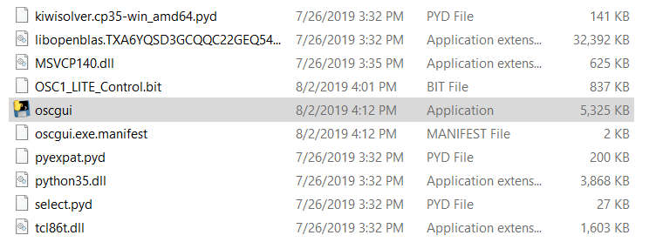

Figure 3 GUI application

* 1. **Connection**

When the GUI window is open, it will actively detect devices before connecting to one. Click on the ‘Connect’ button.

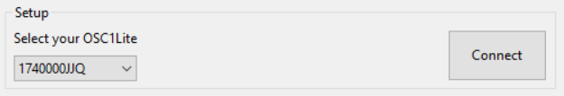

Figure 4 Board connection

* 1. **Parameter Setup**

There are four default waveform on the left side of the GUI. The user can add waveform parameters by clicking on ‘Add New Waveform’ and delete waveforms by clicking on ‘X’ cross button. Each waveform includes six parameters as follows. Hover over a parameter in the GUI for info. The parameter will be applied immediately after the user changes it.

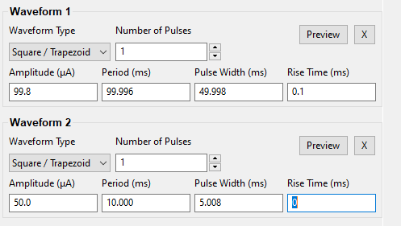

Figure 5 Waveform parameter setting

Table 1 Waveform parameter specifications

|  |  |  |
| --- | --- | --- |
| **Parameter** | **Valid Range** | **Precision** |
| Waveform Type | Square / Trapezoid |  |
| Number of Pulses | Integers from 1 to 65535. |  |
| Amplitude | Integers from 0 to 100 (μA) (Exceeding 100 μA will damage the μLEDs). | ±0.31μA |
| Pulse Width | 0 to 140.000 (ms). | ±8.6μs |
| Pulse Period | 0 to 17,900.000 ms. | ±8.6μs |
| Rise Time | Choose from 0, 0.1ms, 0.5ms, 1ms, 2ms. |  |

Preview the waveform by clicking on ‘Preview’ and a new window will open with the graphic waveform. An example is shown as follows.

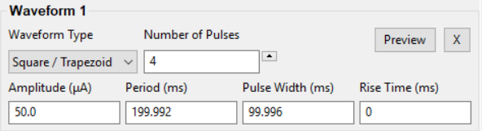

Figure 6 Waveform preview example

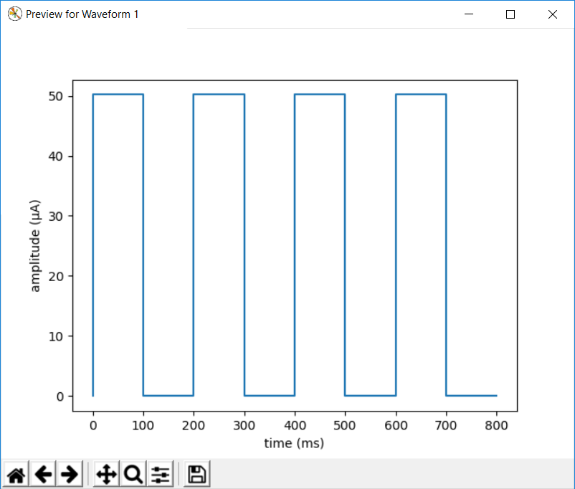

Figure 7 Graphic waveform preview example

* 1. **Stimulation Setup**

After configuring the waveform parameters, the user can now set up the optical simulation on up to 12 channels with the pre-defined waveforms. The changed channel will be marked with an asterisk.

* + 1. **Channel**

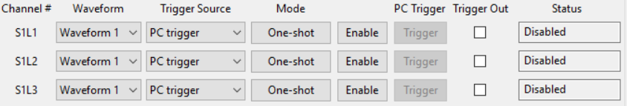

Figure 8 Channels on GUI

The channel numbers are displayed in order on the GUI, from S1L1 to S4L3. ‘S’ represents shank and ‘L’ represents LED. For example, ‘S1L1’ means shank 1 LED 1.

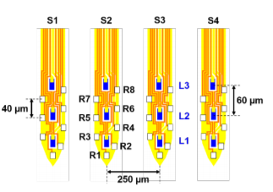

Figure 9 Optoelectrode tip top view

The optoelectrode datasheet is available at <http://mint.engin.umich.edu/wp-content/uploads/sites/327/2019/06/PassiveOptoGen1Datasheet_V1.9.pdf>.

* + 1. **Waveform**

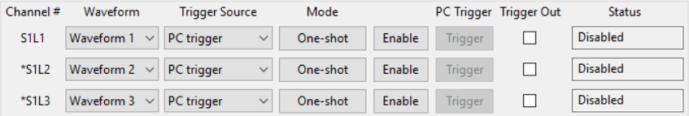

Figure 10 Waveform on GUI

The user can select the specific waveform to stimulate.

* + 1. **Trigger Source**

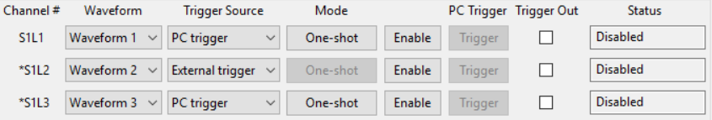

Figure 11 Trigger source on GUI

* + - 1. **PC Trigger**

Stimulate a channel by clicking ‘Trigger’ on GUI.

* + - 1. **External Trigger**

In addition to PC trigger, OSC1-Lite also supports triggering on a rising-edge TTL pulse. If the user selects ‘External Trigger’, the channel will activate the selected waveform for the specific number of pulses if the corresponding External Trigger channel receives a rising-edge TTL pulse.

Following is the mapping between shank numbers and external trigger-in pins on the board.

Table 2 Mapping for external trigger-in pins

|  |  |  |  |  |  |  |
| --- | --- | --- | --- | --- | --- | --- |
| S1L2 | S2L1 | S2L3 | S3L2 | S4L1 | S4L3 | 3.3V |
| S1L1 | S1L3 | S2L2 | S3L1 | S3L3 | S4L2 | GND |

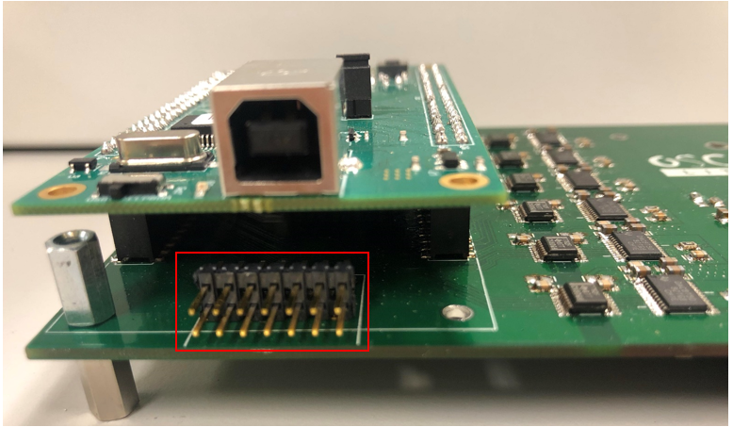

Figure 12 External trigger-in source on board

* + 1. **Mode**

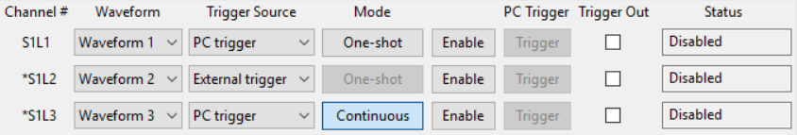

Figure 13 Mode on GUI

* + - 1. **One-shot**

One-shot mode will output a specified number of pulses on channels with parameters defined by the selected waveform. For an external trigger source, the mode is only set as one-shot.

* + - 1. **Continuous**

Continuous mode will assign a continuous wave of pulses with a defined period, duty cycle and amplitude of the selected waveform. The waveform will be continuous until the user disables the channel or re-selects the *Trigger* pushbutton (number of pulses is always neglected when continuous trigger is activated).

* 1. **Stimulation**
     1. **Trigger one channel**

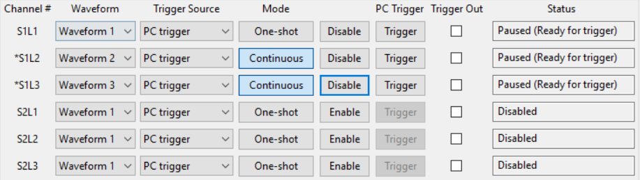

Figure 14 Enable/Disable and PC Trigger on GUI

To stimulate the channel, the user should first click on ‘Enable’ button if the channel is disabled. Then, click on ‘Trigger’ button to trigger the channel if the trigger source is PC trigger. If the user wants to disable the channel, click on ‘Disable’ button.

*Note: The channel will be automatically disabled if it keeps paused (ready for trigger) for 20 seconds.*

* + 1. **Trigger all channels**

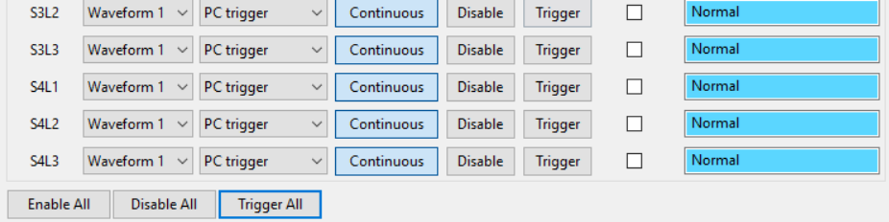

Figure 15 Trigger all channels on GUI

The user can stimulate all channels by clicking on ‘Enable All’ button, and then ‘Trigger All’ button. The user can click on ‘Disable All’ to disable all channels.

* + 1. **Trigger out**

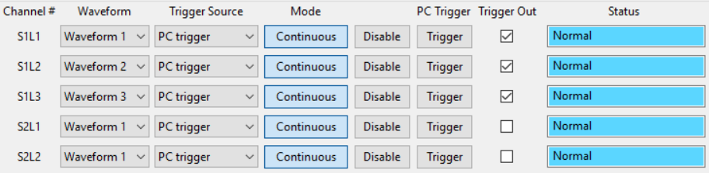

Figure 16 Trigger out on GUI

Click on “trigger out” if the user want to trigger out the signal. The channel mapping between shank numbers and trigger out pins are the same as trigger-in pins in Table 2.

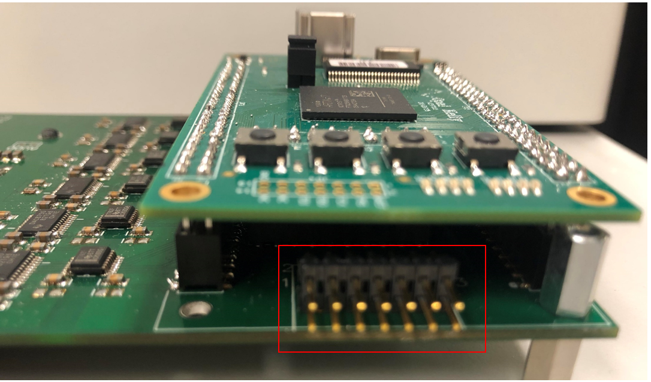

Figure 17 Trigger out on board

* 1. **Channel Status**

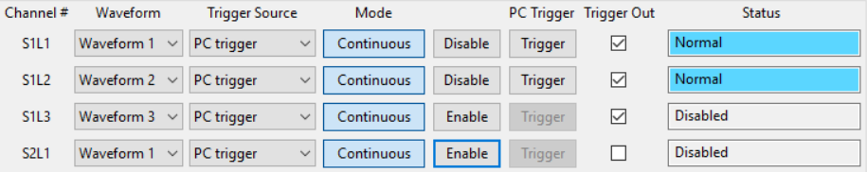

Figure 18 Channel status on GUI

The GUI will show the current status of each channel.

Table 3 Channel status description

|  |  |
| --- | --- |
| **Status** | **Description** |
| Board not connected | The board is not connected to the GUI.  Click on the ‘Connect’ button on GUI. |
| Disabled | The channel is disabled.  Enable the channel if you want to trigger it. |
| Normal | The channel is stimulating the waveform. |
| Paused (Ready for trigger) | There are two possible conditions of the channel.   1. The channel is enabled, but awaiting a trigger. 2. The channel has finished the stimulation, and awaiting another trigger.   If the channel keeps paused status for 20s, the channel will be disabled automatically. |
| Alarm | The alarm will provide explicit error information.   1. If the user sees ‘Open circuit’, check the circuit and wire connection. 2. If the user sees other alarms, reset the system. |

If the μLED is not lighting up normally, please follow the procedure in Section 4.

* 1. **Board Disconnection**

Click on ‘Disconnect’ on GUI. Then, disconnect the USB from your computer and turn off the power on the board.

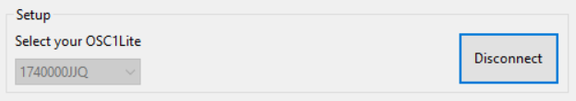

Figure 19 Board disconnection

1. **Open Circuit Test**

The open circuit test procedure is shown as follows.

1. Physically disconnect all μLEDs from the board.
2. Set the waveform amplitude, period and pulse width. Do not leave them 0.
3. Enable and trigger all channels. As all μLEDs are physically disconnected, the GUI should display open circuit. If some channels are displaying other status, these channels may be broken.

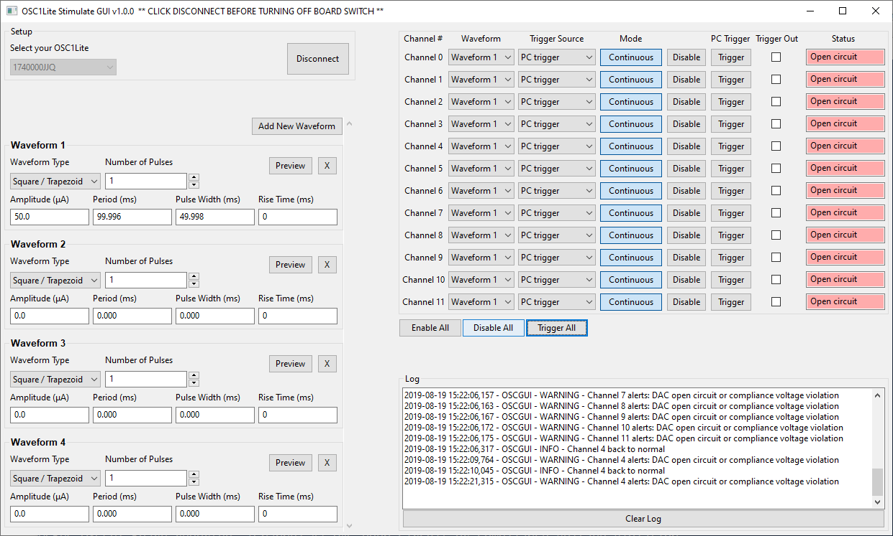

Figure 20 Open circuit test